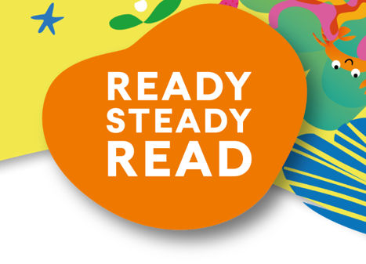
30st January 2024
World Book Day: Thursday 7th March
Dear Parents & Carers,
At Dartington Academy we love celebrating all things related to books. We know that reading for pleasure is a core foundation of all children’s education and forms a key part of our curriculum. We will be celebrating World Book Day on Thursday 7th March. It will a day packed full of reading related fun with all learning focused around reading and books, regular drop everything and read sessions, quizzes and more!
This year, our main focus for the event will be a sponsored read. We will be running this for the full world book day week from Monday 4th-Monday 11th March. All of the money raised during our Ready Steady Read will go towards brand new books for our school. In addition to the sponsorship money, Usborne will also donate up to 60% of the total raised in EXTRA FREE BOOKS to the school. Therefore, the more we raise, the more books we get for free. This is a wonderful opportunity that we hope to make the most of in order to increase the range of books available in our school library.
Please help us to enhance our reading resources for pupils by encouraging your child to spend a small amount of time each day either reading to themselves, to others, or being read to. They can read books, comics, magazines, newspapers, menus, websites, recipes, poems, leaflets, instructions – anything with words!
If you are able to support our sponsored read, please find enclosed a sponsorship form and reading log for your child to record their reading. I wonder who may be able to sponsor our pupils? Neighbours, family members, friends? Any sponsorship money pupils collect can be brought into school during the sponsored read but the final day that it will need to in school by is Wednesday 13th March.
In addition, on World Book Day itself, children may come to school dressed as their favourite book character, if they would like too. Please note this is entirely optional for those who wish to take part. I look forward to seeing all the amazingly creative costumes, showcasing the very best in children’s literature.
At the end of the day, the children will be coming home with their £1 World Book Day voucher that they can exchange for the World Book Day Books or put towards the purchase of a book of their own choice.
I’m looking forward to spending a day celebrating a love of children’s books.
Yours sincerely,

Mrs Eversfield

Assistant Head of School and English Leader

