Dartington Church of England Academy
Nursery Admissions Policy
and Oversubscription Criteria 2021 - 2022

Policy Updated: | Autumn 21
Policy Review  Date: | Autumn 22
As an academy, the Learning Academy Partnership Trust is the admission authority and has responsibility for setting these admission arrangements and for making decisions regarding admissions applications. These schools set their own oversubscription criteria.
These arrangements seek to comply with the government’s School Admissions Code, the Local Conditions of Funding the Early Years Education for two-, three- and four-year-olds and the Early Years Pupil Premium, the Early Education and Childcare Statutory Guidance for Local Authorities September 2014 and the Co-ordinated Admissions Schemes of Devon County Council, the local authority (LA) for this area.

The Ethos of Dartington Church of England Academy
Collectively: We are one team and agree to work together as one family.
Empowering: We invest in each other our communities and our future, achieving more than we ever could individually, whilst preparing for the next stage in our development
Excellence: We champion excellence for all and in all that we do.

Early Years Education Funding for three- and four-year-olds
  - All three- and four-year-olds are entitled to a free early years education place for 570 hours a year over no fewer than 38 weeks of the year. From September 2017 children whose parents are working will be entitled to 1140 hours a year.
  - We expect to admit children that will be using their Early Years Education Funding as well as children whose parents are buying additional hours and those that are both funded and buying hours. There may be some children who are only attending for bought hours and some that only attend for funded hours. The minimum amount of funded time in a day is 3 hours and the maximum is 6.5 hours.

Admissions to the nursery
  - Dartington Church of England Academy admits:
- Three-year-olds from their birth date as paid or eligible to 2-year-old funding.
- Early Years Education funded three- and four-year-olds from the start of term following their third birthday.
- Non-funded three- and four-year-olds from the start of term following their third birthday.

Patterns of attendance available
  - We are required to offer the Early Years Education Funding in a flexible way. Our school makes a core offer of:
- Morning sessions of 9am to 12.00am and
- Afternoon sessions of 12.00pm to 3.00pm and
- All day sessions of 9am to 3.00pm during term time only.
  - If you choose an all-day session this includes the lunchtime period. This time is considered to be part of the day when children continue their learning and will be funded as part of the Early Years Education Funding.

Charging
  - There is no charge for applying for a place, for admission or for the provision of education. We will not request donations before or during the admissions process and any donations made to the school following admission are entirely voluntary. No bought activities, such as visits, are compulsory.
  - The school must comply with Devon County Councils Local Conditions of Funding. A charge cannot be made if a child is only attending the nursery as part of their Early Years Education Funding.
  - Details about buying additional sessions/hours in the nursery are set out in the schools charging policy. A policy on charging for activities is available on request from the school and can be viewed on our website.
  - Non-funded places are also available charged at £4.50 per hour for 3 & 4 Year olds

Childcare Vouchers
  - Our school accepts childcare vouchers (Sodexo, Computer Share and Busy Bees). If your employer has a different voucher scheme please contact the school office to discuss your requirements.
  - For working families, including self-employed we accept Tax-Free Childcare
  - The table below sets out our session times. When applying for a place please tell us what sessions you need. We only consider requests for sessions AFTER the oversubscription criteria have been applied.
Session choices | Hours | Funded/bought hours
9.00am - 12.00pm | 3 | As part of the Early Years Education Funding/free childcare or bought
12.00pm – 3.00pm | 3 | As part of the Early Years Education Funding/free childcare or bought.
9.00am - 3.00pm | 6 | As part of the Early Years Education Funding or bought.

  - Parents only wishing to use their 15 funded hours with us need to choose sessions carefully so that they can access the full 15 hours e.g. sessions of 6 + 3 + 3 + 3 hours = 15 OR 6 + 6 + 3= 15. 3+3+3+3+3 hours = 15.
NB The funding can only be taken between 9amam. and 3.00pm.

School Lunches
  - If your child is entitled to FSM and attend nursery for both before and after lunch sessions, a free school meal can be provided. The same benefits criteria apply to nursery school children as apply to children in school.
  - Registered nursery children who do not meet the eligibility criteria for free school meals can pay for a school lunch or bring a packed lunch or both.

Visiting
  - We welcome visits from parents and children who are considering applying for a place here. This is an opportunity for you to see what we have to offer. Visits are not a compulsory part of the admissions process and will not affect decisions on whether a place can be offered at our nursery. If you would like to visit, you should contact the school to make an appointment.
  - Home visits will take place prior to your child starting.
  - Stay & play and taster sessions are offered when places have been accepted. The Nursery lead will also discuss a phased start if required.
  - Most children will start at the nursery at the start of the term. Other children join us “in-year” at other times. This may be because they are new to the area or would like to transfer from another school or early years provider.
  - To apply for a place , please complete the expression of interest form or School Nursery Application Form.
  - Places are not allocated to a child automatically, even where:
- there is an older sibling attending here;
- a child attends a particular toddler group or Children’s Centre attached to the school;
- a parent has expressed an interest at any time in the school; or
- the child has always lived close to the school.
  - No places will be held in reserve for a child who applies late; the school cannot hold places empty if another child applies for admission. We will publicise the need to apply but the responsibility for making an application will be with you as the parent.

How to apply for a nursery place
  - Parents may complete an Expression of Interest form for all children 1 year old and under. Parents who wish to apply for a 3 year old place must complete the School Nursery Application Form and return it to the school.
  - The closing dates for applications for the nursery intake are: 1 May l (for a September start), 1 October (for a January start) and 1 February (for an April start). You can apply after these dates but your application may not be considered until after all of the applications that were on time. If you couldn’t apply before because, for instance, you moved to this area, you should make sure that you inform the school. If the reason for applying after the closing date is accepted, your application will be considered at the same time as everyone who did apply on time if this is still possible.

Information provided in an application
  - We would like all applications to be fully and honestly completed. It is important that where we offer places to some and refuse others we do so fairly and consistently. Where we have reason to believe that information is false and has been provided knowingly we may withdraw the offer of a place. This is particularly relevant where an address is given which is not the one from which a child will actually attend nursery and this disadvantages another child. If necessary, we will ask for evidence of a child’s home address and date of birth before admission.
  - If you know or believe that your child’s address will change before admission, you must inform the school as this may affect your application.
  - You will be asked to provide date of birth evidence so we can check your child’s age.

What happens next
  - If there are fewer applications than places then no application will be refused. Only if there are more applications than there are places available will the Trust prioritise applications according to the oversubscription criteria below.
  - By 1 June , 1 November and 1 March we will contact successful parents to welcome them to the nursery and to make arrangements for admission itself. You will also be contacted if we do not have a place available so that you can apply to another provider.
  - If you need help finding a place at another provider please visit https://www.pinpointdevon.co.uk/

Points of Admission to nursery for funded hours
  - Generally, children will start at nursery at the beginning of a term, as defined by the DFE. Eligibility for all three-years-olds to receive the Early Years Education Funding is at the start of the term following their third birthday. This funding will be paid up until the time when the child reaches statutory school age if the parent chooses to defer or delay entry into school.
Children who are eligible 3 year olds
On or after | And on or before | Funding starts:
1 September | 31 December | Spring (after Christmas)
1 January | 31 March | Summer (after Easter)
1 April | 31 August | Autumn (after Summer)

  - There is a legal requirement that all children begin full time education by the beginning of the term following their fifth birthday. All places offered in reception at the normal round are for full-time admission in the September following the fourth birthday. This is a legal requirement on schools but not on parents who retain a right to defer admission or send their child part time.

The Admissions Process
- Children become eligible for a place when they were born: | On or after 1 April and on or before 31 August | On or after 1 September & on or before 31 December | On or after 1 November & on or before 31 March
- Visit the nursery in: | Spring term | Summer term | Autumn term
- Apply by: | 1 May | 1 October | 1 February
- Admissions panel meet in: | May | October | February
- Receive a letter about your application before: | June | November | March
- Reply to the letter | Reply to the letter within 2 weeks to accept a place (or ask why you did not get a place). You can telephone, email or write to the school
- Start at Nursery  (or at the start of term closest to that month) | September  Autumn Term | January  Spring term | April  Summer term

Published Nursery Admissions Number (PNAN)
  - This is the number of places we intend to make available for our normal nursery intake. Once we set this number, we will not refuse admission for applications below the PNAN. If there is unexpectedly high demand and we believe we could admit more children, we inform Devon County Council’s Early Years and Childcare Team and either some children will be admitted above the PNAN or we will increase the PNAN. The number of children that can be admitted will depend on their age, the amount of floor space we have and whether additional staff will be required.
  - The Trust also factors in the local demand for places. If there is a change to the PNAN part way through the year this must be published.
  - If there is an increase in the demand for places, the Trust may decide to increase the PNAN at the start of the following term in order to accommodate children on the waiting list and conversely reduce the PNAN if there is a very low demand.
  - The table below sets out our Published Nursery Admissions Number (PNAN) for 2021-22
The maximum number of 3 and 4 year old children that will be admitted at any one time: | 30

  - Where the number of applications exceeds the number of places available the Trust will use the following oversubscription criteria to prioritise applications for both funded and bought hours:
A child with an Education, Health and Care Plan naming the nursery will be admitted.
Looked After Children or those who were Looked After but ceased to be because they were adopted, made the subject of a child arrangements order or made the subject of a special guardianship order.
Priority will next be given to children with an exceptional medical or social need to attend this setting.
Priority will next be given to children who live in the catchment area set out in the map below, who are eligible for the Early Years Education Funding for two-year-olds.
Priority will next be given to children living in the school’s catchment area, who are siblings of pupils on roll at this nursery or school when the application is made.
Priority will next be given to children of members of staff who have been employed at this school for more than two years when the application is made or recruited within the past two years to fill a vacancy for which there was a skills shortage.
Priority will next be given to children living in the school’s catchment area,
Priority will next be given to children who live outside the catchment area who are eligible for the Early Years Education Funding for two-year-olds.
Priority will next be given to children living outside the school’s catchment area, who are siblings of pupils on roll at this nursery or school when the application is made.
Other children who live outside of the catchment area
Tie breaker – to prioritise applications in the same oversubscription criterion, we will use: a) straight-line distance from home to school and, b) where distances are equal (within a metre) we will use a Random Ballot.
15 Exceptional social or medical need for admission to our nursery.
15.1 We give higher priority for children where there is an exceptional social or medical need to attend this nursery. The need must be specific to this nursery: the child may have very challenging circumstances that requires additional support but if that support could also be provided at another nursery, there would be no exceptional need to attend this nursery. Exceptional social or medical need could include:
- A serious medical condition, which can be supported by medical evidence;
- Significant caring responsibilities, which can be supported by a social care officer;
- Where the child has a disability that may make travel to another nursery more difficult, which can be supported by medical evidence.

15.2 These examples aren’t meant to be exhaustive or exclusive. Neither should it be assumed that similar circumstances would impact on different children and families in the same way.
16 Catchment Area
Our catchment area is in the middle of the map, bordered by a light blue line. You can view it in more detail at devon.cc/schoolareamaps. This will confirm whether addresses close to the boundary are inside or outside our area. We welcome admissions applications for children living inside and outside our catchment area.

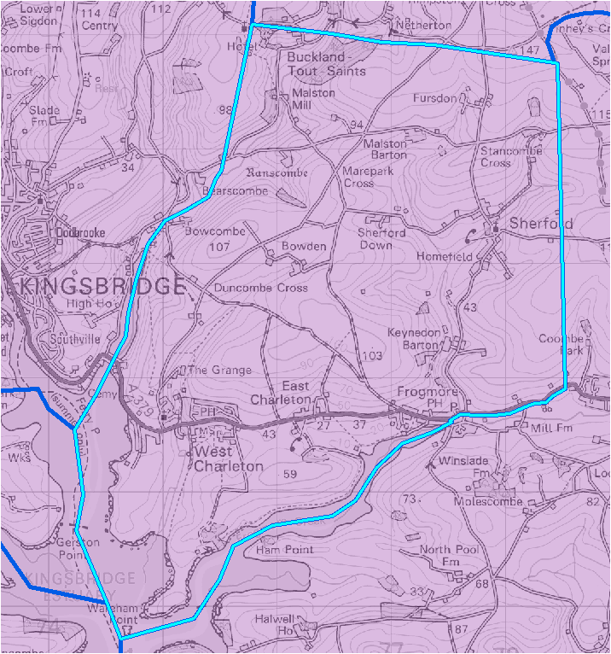
© Crown Copyright. All rights reserved. Devon County Council 100019783 2017

17 Waiting lists

17.1 Following the allocation of nursery places the school will retain a waiting list. Waiting lists will be kept in order of the oversubscription criteria above. Places on lists will not be prioritised according to how long a child’s name has been on that list or by the age of the child or by whether the sessions are funded or bought. It is possible that a child’s name could go down on a list as well as up.
17.2 If a place is only available for a short period of time, i.e. half a term or less, then the school will discuss with the parent whether it would be in the child’s best interest to attend the nursery for such a short period of time before having to find a place at another provider. Continuity and consistency of care is most important in the early years and having lots of transitions can be disruptive for a child.
17.3 Parents with very young children, i.e. those that are not due to start within the next two terms, will be asked to complete an expression of interest.

18 Increasing the hours attended
18.1 If a place becomes available part way through a term and there is a waiting list, priority for the place will be given to the child/children on the waiting list. If the parents on the waiting list do not want the places as the times that are available then the places can be offered to parents of children who are already attending the nursery. Similarly, if there is not a waiting list and there are parents of children that already attend the nursery who want to either take up additional funded hours and/or buy extra hours then a list of those parents will be made and the oversubscription criteria will be applied to determine who should be given priority for that place.

19 Admissions appeals
19.1 If a nursery place is refused, parents can go through the schools complaints process to express their concerns. The Trust will review the decision and decide whether the refusal was justified on the grounds that the nursery is full. Even if it is agreed that the nursery was full, it will also consider the impact on the child and family and may still award a place at the nursery if there is both the physical space and sufficient staff available.

20 Transport
20.1 No transport is available for pre-school children.

22 Claiming the Early Years Education Funding
22.1 The Early Years Education Funding can be taken at more than one provider. Although there is no upper limit on the number of providers a child can attend careful consideration must be given to ensuring that the child feels settled, safe and can form relationships with significant adults.
22.2 It is important that both the school and parent can see what time is funded and what time is being bought.
22.3 Parents must not claim more than the 15 hour entitlement, checks are carried out to ensure that over claims are not made.
22.4 All 3 and 4-year-olds in England already get 15 hours a week, or 570 hours a year of free early education. If their parents are living and working in England, 3 and 4-year-olds may be entitled to 30 hours free childcare. An extra 570 hours of free childcare a year, so 1140 hours in total. 30 hours free childcare will be available from September 2017.

22.5 The eligibility criteria are the same as the ones for Tax-Free Childcare, except you can continue to get these types of support at the same time as 30 hours free childcare:
- tax credits
- Universal Credit
- childcare vouchers or salary sacrifice schemes
- childcare grants and bursaries
22.6 When you apply, you'll be confirming that you need childcare so that you and your partner, if you have one, can work. If your child's already in a full-time reception class in a state funded school, you won't be eligible for 30 hours free childcare
22.7 You may be asked to help complete a Conflict Buster and Parent Declaration Form if you want some funded time with us and some at another provider.

23 Changes to attendance
23.1 Changes to the times when a child is attending will generally only be agreed to take effect from the start of a term. The oversubscription criteria will be applied to both 1 and 2 below to determine within each group which children should be given priority. Order of priority for the consideration of unfilled places.
- New applications from parents whose children do not yet attend the nursery.
- Requests by parents whose children attend the nursery and they want to increase OR change the times their child attends
23.2 It is expected that parents will ensure that their child will attend at the times agreed on so that children can establish a routine and be ready to start school.
23.3 If a child is sick the parent must inform the school. If a child does not attend the nursery for a period of more than two weeks without informing the school that child’s place may be offered to another child.

24 Induction and transition arrangements for starting nursery/FSU
24.1 The nursery provides outstanding early years provision for all children aged two, three and four years. All children will experience the exciting, stimulating learning activities planned to support your child’s learning based on their interests and their next steps to ensure they are able to progress to their highest potential. We aim to develop a broad and balanced curriculum to stimulate your child to acquire knowledge and develop individual skills. We see the unique child and we actively help them to grow and develop into a capable, confident and self-assured individuals. Every child is constantly learning in a rich environment both indoors and outdoors with stimulating resources to excite them and ignite their learning. We learn in a fun, practical, purposeful and playful way so learning is fun and relevant to the world and the children are encouraged to explore and take initiative in their own learning.

24.2 Following your nursery and academy tour and acceptance of place , you will be asked to arrange a suitable date for us to come along and meet with you and your child at your home. This allows us to discuss your child’s interests, past experiences and any questions or concerns you may before they begin their journey into nursery. To ensure that your child’s transition is made as smooth as possible we will then invite you both to a stay and play session and arrange a staggered start if necessary.

25 Contacts and further information
Mrs Huish, Head of Academy | E-mail: | dartington@lapsw.org
 | Telephone: | 01803 862357
 | Website: | dartington-lap.co.uk

26 Policy Version
26.1 This policy was determined by the Trust on 24th September 2021

The Local Conditions of Funding are continually being updated so please make regular visits to the document.

