Sex Education Y6 Parental Information

This is the non-statutory part of Relationships, Health and Sex Education Curriculum and will be taught in Y6. Whilst Sex Education (which goes beyond the national curriculum for Science) is not compulsory, it provides an important transition phase before moving to secondary school, supports pupils’ ongoing emotional and physical development effectively. The Department for Education continues to recommend, therefore, that all primary schools should have a Sex Education programme.
To ensure that we support our pupils to be ready for their next stage of education, develop the resilience and confidence to flourish in life, Sex Education in the final year of Primary school will give children the confidence to understand about the world around them and to be empowered to make safe and wise decisions, both in the online world and wider. In doing this, we aim to assist the overall development of pupils as members of society by fostering positive and reflective attitudes about themselves and relationships, and on life and health issues. We will be drawing upon the nationally recognised programme of study, The Christopher Winter Programme, which builds upon the ‘Changing Adolescent Body’ learning which Y6 pupils will have had in the preceding lessons in Y4 and Y5.

This information is designed to be an overview of the learning over a series of lessons, to support parents to work in partnership and continue conversations at home by knowing what the children are learning.

Lesson 1: To consider puberty and reproduction

Children will recap the changes for both girls and boys during puberty. This includes an overview of menstruation (periods) as well as information about boys experiencing erections and wet dreams so that children know these are all common for girls and boys, respectively.

Key Vocabulary: Penis, scrotum, public hair, nipples, breasts, uterus, ovaries, vagina, vulva, clitoris.
Here are some examples of the resource pictures:

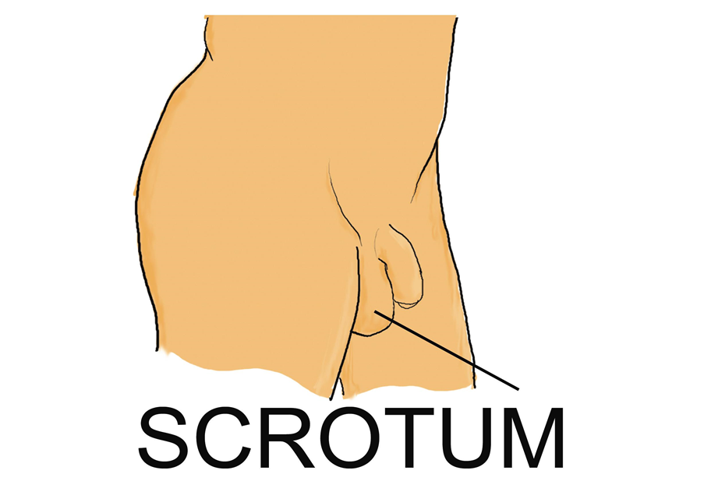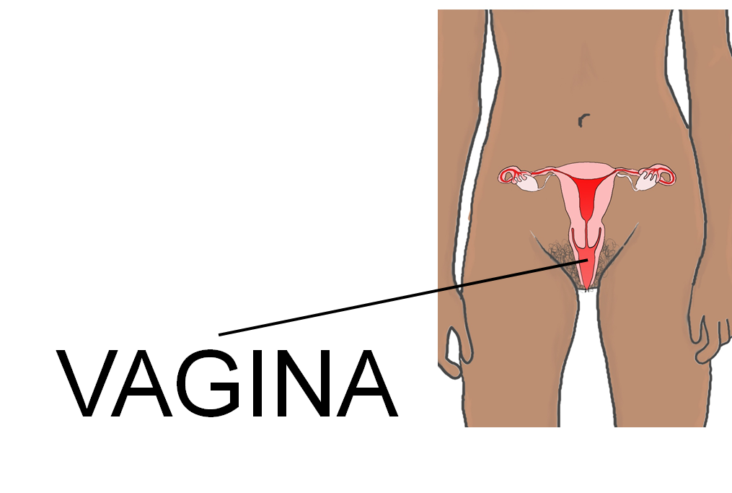

Lesson 2: Exploring the importance of communication and respect in relationships

Children will learn about what makes a healthy friendship and the different types of relationships people may have. Children will learn about different types of touch and the importance of communication about what is appropriate. Children will also learn how to seek help if they are uncomfortable with a relationship and their rights to always feel safe.
Key Vocabulary: Healthy Relationship, ‘going out’, communication, comfortable/ uncomfortable.
Here is an example of a discussion point around appropriate, or healthy, touch:
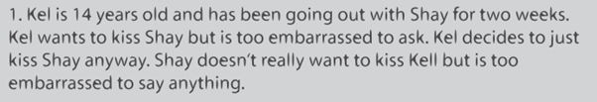

Lesson 3: To consider the different ways people might start a family. (This may be split into 2 sessions)
Part A
In this part of the lesson, the children will discuss the big decisions grown-ups make when planning to have a family. This links back to previous learning about communication and healthy relationships. As part of this, the children will discuss that families are all special and uniquely different, not all families, for example, have children and not all families have a mum and a dad.

Part B
In this part of the lesson, the children will learn an overview about how a baby is conceived and then develops in the womb. This learning about sexual intercourse will be contextualised within the learning about healthy adult relationships. Children will also learn that there are other ways (other than sexual intercourse) by which families can have a baby, such as adoption, fostering and IVF.

Any questions, asked by the children, that go beyond the programme of study (such as about contraception) will be carefully answered (so as not to dismiss) informing the children that they will learn more at Secondary School and refer the children to their parents, for further guidance/information, at this stage.
Key Vocabulary: Touching, adult couples, agree/consent, sexual intercourse (sex), sperm, egg, fertilised, conception, pregnancy, womb (will also use the correct words for genitalia for both males and females, as per Changing and Growing unit in previous block).

Here are some examples of the resource pictures:

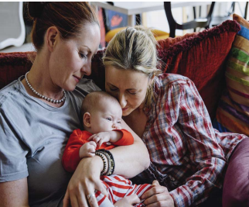

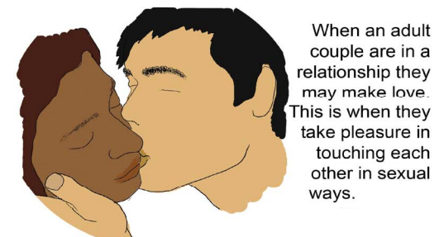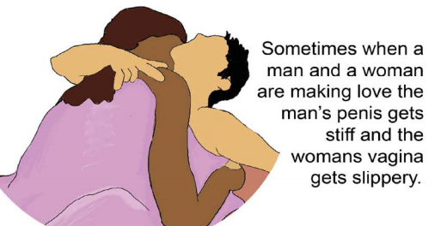

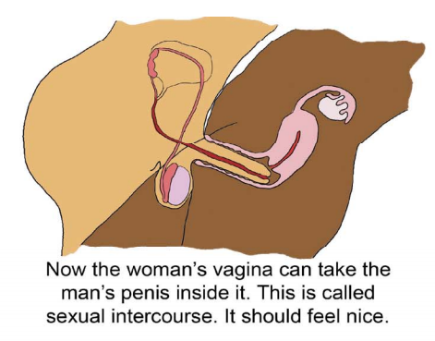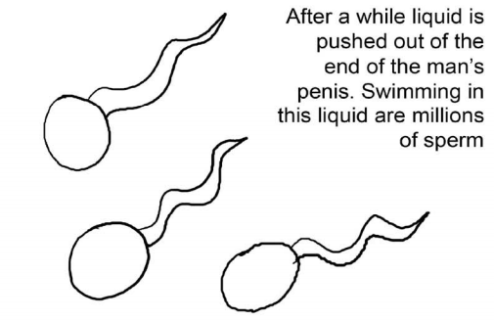

Lesson 4: To consider how to keep safe, with whom and when it is appropriate to share personal information, including on phones and the internet.
This learning relates back to learning on different types of relationships, what makes a healthy relationship and the importance of trust and communication. Children will explore how they keep themselves safe and how to use their learning to help them make wise choices when considering sharing any personal information with others, online or in person.
The children will become familiar with several ‘trusted sources’ of support including these websites:
https://www.thinkuknow.co.uk/8_10/
https://www.childnet.com/
https://www.childline.org.uk/

Key Vocabulary:
Healthy relationship, personal information, email, phone, social media, photos, communication.

